Annex F – Statement of Work (SoW)

Online Platform/Content Development

- Introduction

  - Project: “Increased livelihoods opportunities and improved resilience for returnees and host communities in South East Abkhazia through sustainable, innovative and effective partnerships”.

  - General Context:
In the absence of relevant institutions in the form of VET colleges in Abkhazia in the sector of agriculture, given the small number of agro-experts available in remote areas for consultations and training, while considering the fact that farmers have limited access to information in general, this intervention purely focuses on capacity-development and awareness-raising of farmers in Abkhazia.

Hence, the present online platform/ content development is meant to support farmers to increase resilience and adequately fight pests. To tackle skills and professional development of farmers through videos and online media claims to be innovative in terms of livelihood support as it introduces for the first time in Abkhazia new tools and paths for farmers to increase their knowledge, acquire new skills and practices to effectively limit the effects of various pest infestations since 2017 and maintain yield levels at a decent level.

The overall goal is to create a learning catalogue for farmers. 15 produced videos accompanied with tips in the form of articles with pictures, and a new online platform so to serve as training materials for farmers and guide them in each step of their activity to prevent and limit the damaging effects of the pests in Abkhazia.
This action is considering one sector with the intention to be expanded through potential engagement of RDA (Rural Development Association), established as a spin off organisation in 2017 to ensure sustainability.

- Subject: Online Platform/Content Development - to facilitate the upgrading of existing online web-site, produce 15 educational videos relevant to farming, crop management and pest management in Abkhazia (filming on site is separate and to be coordinated by DRC (Danish Refugee Council)) and at least 15 tips (articles and pictures) and technical assistance module

- Required Deliverables:

- Development of an online support platform with special focus on upgrading the already existing RDA web-site;
- Technical support to the production of 15 educational videos - Content development per topic, tips and articles (design and production); the videos shall approximately 3-4 minutes long and cantered on interviews with key experts with subtitles in local languages. Where needed, the text and graphics, visual effects to be integrated into the videos;
- Production of 15 Power tips articles which include text and images to be posted in the website in two languages, Russian and English;
- Technical assistance for upgrading of host platform, training of staff and uploading of materials.

- Technical specifications required as per deliverables:

- Platform
Resource-intensive, highly functional, and optimized site for storing the files and high volume of data/information efficiently which must denote and integrate the following technical functionalities
- User-friendly wireframe
- Stronger domain: important for speed/performance, turnaround time for web-site files;
- Stronger diskspace: essential for storing resource intensive information;
- Stronger databases/Email addresses: number of individual pieces of software/users we can place on the account;
- Search engine optimization feature;
- Social Media integration;
- Visitor analytics;
- Responsive design, provide RSS feed and an e-mail subscription option

AA) Part of the platform development:
- A consultancy module that allows users to ask questions to RDA (Rural Development Association) agronomists

B and C) Content (text and Video)
- video tutorials relevant to farming crop management and pest management in Abkhazia.
B 1) Bidders must present the bullet point script for each video.
B 2) Each video must be 3-4 minutes long and centered on interviews with key experts in the field. The final videos should meet the following criteria:
- Format: MPEG2, at 24p or 25p.
Final (edited) video export settings:
- Format: H.264
- Preset: custom
- Resolution: 1920/1080
- Bitrate encoding: VBR, 1 Pass
- Target bitrate [Mbps]: 24
- Maximum bitrate: 50
- Key frame distance: 72
Audio export settings:
- Audio Codec: AAC
- Sample Rate: 48k HZ
- Audio Quality: High
- Bitrate [Kbps]: 192

It is important that “Maximum Render Quality” is used.
As per example here

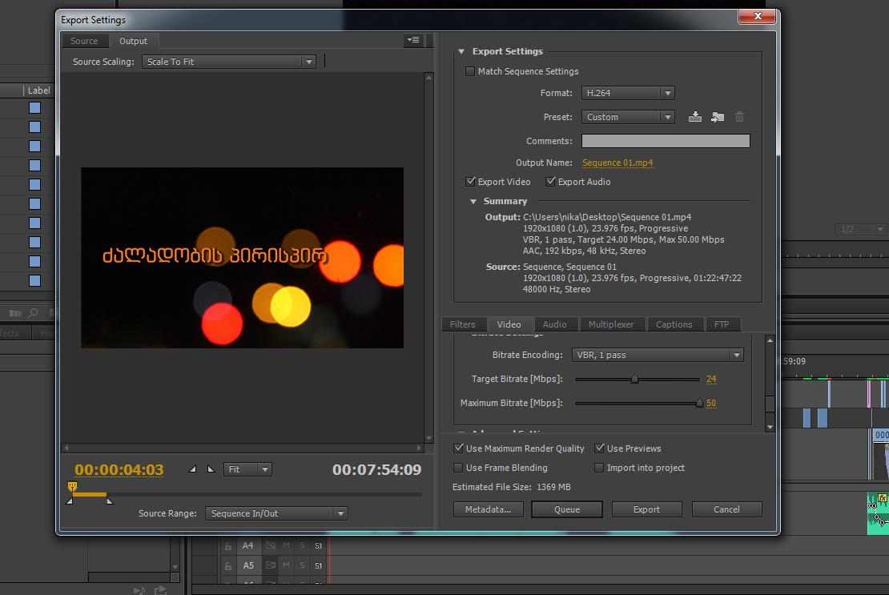

D ) Technical assistance; training of staff; uploading of materials.

A Technical assistance module that allows RDA to
  - Update content on the platform.
  - Answer consultations by users.
and covers the following:
- RDA web-site gap analysis and upgrading the host platform inline with the required technical functionalities outlined above under the section 4.1
- 7 days training for DRC and RDA representatives (max 4 persons) on platform management covering aspect of uploading the different materials, updating the content, and follow up maintenance.

Note: All potential bidders are required to develop and present the detailed budget in addition to required Financial bid Annex A 2. which allows us to examine the financial and operational aspects of provided Services.

- Tentative dates and Timeline for this activity:

Deliverables | Tentative delivery date
1. Project Initiation
1.1 Approval of project timeline and video topic list | 25 April 2019
1.2 Field visit (video shoot, wireframing session) | 20 May 2019
2. Video Production
2.1 Batch 1 (6 videos)
2.1.1 Video script development | 12 April 2019
2.1.2 Selection of interviewees (local experts) | 20-21 May 2019
2.1.3 Shooting, editing and initial post-production | 22 May-25 June 2019
2.1.4 Quality control | 25-29 June 2019
2.1.5 Publication | 30 June 2019
2.2 Batch 2 (3 Videos)
2.1.1 Video script development | 1 July 2019
2.1.2 Selection of interviewees (local experts) | 22- 23 July 2019
2.1.3 Shooting, editing and initial post-production | 30 July – 25 August 2019
2.1.4 Quality control | 29 August 2019
2.1.5 Publication | 1 September 2019
2.3 Batch 3 (6 Videos)
2.1.1 Video script development | 10 September 2019
2.1.2 Selection of interviewees (local experts) | 15-18 September 2019
2.1.3 Shooting, editing and initial post-production | 20 September – 25 October 2019
2.1.4 Quality control | 27 October 2019
2.1.5 Publication | 30 October 2019
3. IT development
3.1 Wireframe Development | 5 May 2019
3.2 Wireframe Evaluation and Approval | 10 May 2019
3.3 Gap analysis of the existing RDA web-site | 20 May, 2019
3.4 Migration of existing data | 20 May 2019
3.5 Upgrading of RDA web-site//adding functionalities | 30 May 2019
3.6 Content development (Power tips text, images) | May- August 2019
3.7 Testing and QA | May – October 2019
3.8 Staff Technical assistance - training | September 2019

